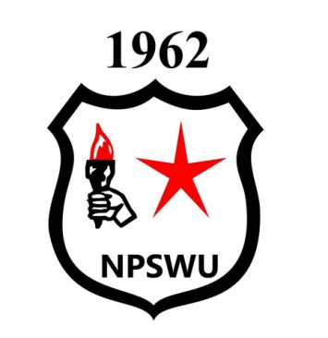
NATIONAL PUBLIC SERVICE WORKERS UNION (NPSWU): STATEMENT ON NATIONAL TREASURY EXCLUSION OF PUBLIC SERVANTS ON PENSION FUND WITHDRAWAL
NPSWU rejects National Treasury statement with contempt it deserves ON the exclusion of public servant pension withdrawal. In their statement, it said that “ the Government recognized that many members may need to access part of their savings in particular unexpected circumstances “ it is shocking that they recognise that workers may need to access part of their saving, but for some reason feels that public servant do not need to access such . What is even more painful is that the same government failed to pay salary increase of public servant for 2020 even to show a token of appreciation with a once of bonus to show the heroes and heroines that they indeed fought an enemy without any artillery.
That alone is enough “unexpected circumstances “for public servant. The same public servants who are excluded from pension withdrawal, majority of them are essential service workers who who are and still in the forefront for fighting Covid -19.
NPSWU view this as an attack on the workers which started when Government reneged to pay salary increase for 2020. What is even more painful and unacceptable is that majority of public servant are black, taking care of not less than five people. So treasury statement that excludes public servants is a deliberate attempt to keep black people on absolute poverty and force them to be slaves of financial sectors which are owned by white monopoly capitals and as thus indebted for life
NPSWU is aware that GEPF law is governed by their own law but it is not impossible to amend such law as long as there is a will.
We call on Treasury to stop provoking workers and pushing them to the edge, everyone has a breaking point. Once public servant reach a breaking point, and embark on tools down, the country will come to a standstill and ordinary poor south African will suffer.
We call on national treasury to reconsider their poor decision and push for the amendment of GEPF law to allow for fund withdrawal by public servants
We will not relent; we will not equivocate, forward with the workers emancipation forward
For more info contact info@npswu.org

AMAAANDLA !!!

